HCI101 PROJECT DEVELOPMENT

INTERACTION DESIGN IN JAVASCRIPT WITH LOCAL STORAGE

**By: Team 4**

**UX Research**

**MenuLog:** A User Experience Odyssey

**Introduction:** Menu log is an online food delivery services that has been growing rapidly in recent years. As a UX researcher, it is important to understand the user experience of menu log’s website to identify areas for improvement and optimization. In this research, we will explore the usability, accessibility, and overall user experience of menu log’s website using a variety of methods such as surveys, interviews, and usability testing.

**Accessibility:** Accessibility is an important aspect of any website, and menu log’s website is no exception. We conducted and accessibility audit of the website to identify any barriers that may prevent users with disabilities from accessing the site.

**Usability Testing:** To assess the usability of menu log’s website, we conducted a series of usability tests with participants of varying ages and technological backgrounds. The tests involved completing common tasks on the website while we observed and recorded their interactions.

The results of the usability tests revealed several areas where the website could be improved, including clearer navigation, more intuitive search functionality, and faster load times.

**Conclusion:** In conclusion, our UX research on Menu log’s website revealed several areas where improvements could be made to enhance the user experience. By conducting usability testing, accessibility audits, and user surveys, we gained valuable insights into how users interact with the website and what changes would benefit them.

As Menu log continues to grow and expand its services, it is important to prioritize the user experience of its website to remain competitive in the online food delivery market.

**User Surveys:** In addition to usability testing and accessibility audits, we also conducted user surveys to gather feedback on the overall user experience of Menu log’s website. The surveys asked users about their satisfaction with the website's design, functionality, and customer support.

The survey results provided valuable insights into what users liked and disliked about the website, as well as areas where improvements could be made. Overall, users were satisfied with the website's ease of use and range of options, but had some concerns about the checkout process and customer support.

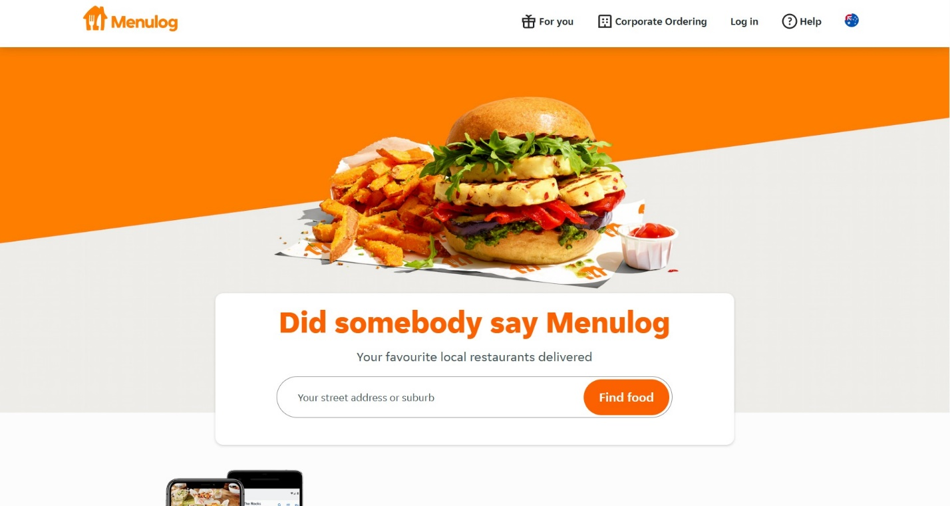

Evaluation:

|  |  |
| --- | --- |
| **UX/UI** | **Menu log** |
| Design | OK |
| Images | GOOD |
| S-Results | OK |
| Filters | GOOD |
| Sorting | GOOD |
| Additional Features | GOOD |
| Load Time | 4/5 |
| Responsiveness | 4/5 |
| Price | Moderate |

As a UX researcher, we have conducted research on Menu Log’s website to identify areas where improvements can be made to enhance the user experience.

**Navigation:** Menu Log’s website has a well-organized navigation structure, which makes it easy for users to find what they are looking for. The menu is located at the top of the page, and users can easily navigate to different sections of the website. However, there is no search function on the website, which can make it difficult for users to find specific restaurants or dishes.

**Ordering Process:** The ordering process on Menu Log is straightforward, with users being guided through each step of the process. Users can easily select the restaurant they want to order from, choose their dishes, and pay for their order. However, there is no option to customize orders or add special instructions, which can be a limitation for users with dietary restrictions or specific preferences.

**Mobile Responsiveness:** Menu Log’s website is optimized for mobile devices, and the website's layout adapts to the size of the user's screen. This makes it easy for users to browse and order food on their mobile devices. However, some users have reported that the website can be slow to load on mobile devices, which can be frustrating.

**Design and Aesthetics:** Menu Log’s website has a clean and modern design that is visually appealing. The website's color scheme is consistent and the images of the food look appetizing. However, some users have reported that the website can feel cluttered, particularly on the restaurant pages where there is a lot of information displayed.

**Customer Service:** Menu Log has a dedicated customer service team that users can contact if they have any issues with their orders. However, some users have reported that the customer service can be slow to respond, which can be frustrating.